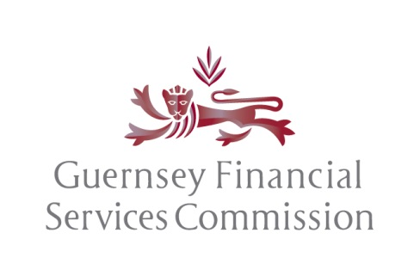

APPLICATION IN RESPECT OF A PROPOSED LICENSEE SERVICING A QUALIFYING INVESTOR FUND, A REGISTERED COLLECTIVE INVESTMENT SCHEME OR AN OVERSEAS COLLECTIVE INVESTMENT SCHEME

COMPLETION OF FORM FTL:
- The Form FTL and Form RA/1 should be submitted electronically together with a covering letter scheduling the associated documentation being submitted in support of this application to authorisations@gfsc.gg. For large submissions please use Egress. The Form FTL and Form RA/1 will be processed in 10 days.
- Online Personal Questionnaires and/or Online Appointment Forms (as applicable) should be submitted by individuals proposing to hold supervised roles in the Licensee.
- If the Applicant is proposing to act as a manager in respect of open ended overseas collective investment schemes a Form NGSF should be submitted with this application.
- If the Applicant for a Licence as a manager to overseas collective investment schemes is intending to migrate into the Bailiwick of Guernsey Form FTLM 2021 (Fast Track Licence Migration) should be used.

Name of Applicant for a Licence

Declarations by the Proposed Administrator of the Applicant for a Licence-

- I confirm that we, the proposed administrator of the applicant for a licence, have performed sufficient due diligence to be satisfied that the beneficial owners or controllers of, and relevant parties to, the applicant for a licence are fit and proper and meet the requirements of Schedule 4 to the Protection of Investors (Bailiwick of Guernsey) Law, 2020 and that in this respect consideration has been given to all of the issues set out in the Guidance Document issued by the Commission dated November 2021.

- I confirm that we, the proposed administrator of the applicant for a licence, confirm that the application for a licence under the Protection of Investors (Bailiwick of Guernsey) Law, 2020, which includes Form RA/1 and supporting documentation and information, is complete and accurate and that we have undertaken sufficient due diligence to support such conclusion.

- I confirm that the information supplied is complete and correct to the best of my knowledge and belief at the time of submission and that there are no other facts material to the application of which the Commission should be aware.

- I am aware it is an offence, under the legislation in respect of which the Commission exercises its statutory functions, to knowingly or recklessly provide the Commission with information which is false or misleading in a material particular.
Documentation submitted

In support of the application, we confirm that the following documentation/information is enclosed with this form or has already been submitted electronically:

- Fully completed, signed Form RA/1;

- Confirmation that online Personal Questionnaires and online Appointment Forms (as required) in respect of controllers, directors and senior managers of the applicant (as appropriate), have been submitted through the portal;

  - All documentation and information referred to in Form RA/1 in support of the licence application;

  - Confirmation that the applicant has been incorporated or established (as appropriate);

  - Documentary evidence such as bank statement and Board minutes supporting the applicant’s paid up share capital, together with the relevant directors’ confirmation in respect of the applicant’s financial resources provisions (as required under 2.1.1 of the Licensees (Capital Adequacy) Rules and Guidance, 2021

  - A copy of the administrator’s due diligence supporting the declarations referred to above, together with the administrator’s documented assessment of the fitness and properness of the applicant for a licence, (See Note 1);

- The application fee required under the relevant fees regulations;

- Where the applicant will be conducting restricted activity in respect of overseas collective investment schemes, a fully completed Form NGSF for each open ended scheme (see Note 2) and the names, jurisdiction and regulatory status of any closed ended schemes.

Signed (See Note 3) |  | Date
Name and position
(See Note 4)
Institution
(Proposed administrator )
Address

Telephone number

Notes

Note 1: This documentation will not be returned to the administrator unless specifically requested. The administrator may be subject to a post facto review by the Commission of its due diligence on the applicant

Note 2: The Form NGSF (Non Guernsey Scheme Fast Track) may be adapted for more than one overseas collective investment scheme and efficiencies in our review will be sought where possible however; depending on the number of schemes and the variances between them up to 2 days per scheme for processing may be required. This is in addition to the 10 days for processing the Form FTL and Form RA1. A fee will be charged for each individual scheme up to 25 promoted by the same party, thereafter the Commission may at its absolute discretion vary the fee.

Note 3: The form must be signed by a director, or in relation to an unincorporated body, any member of the committee or similar governing body, of the administrator.

Note 4: The Data Protection (Bailiwick of Guernsey) Law, 2017

For the purpose of the Data Protection (Bailiwick of Guernsey) Law, 2017 please note that any personal data provided to the Commission will be used by the Commission to discharge its regulatory activities and statutory functions. Further information, relating to the Commission’s Data Protection policy, can be located on the website at www.gfsc.gg/data-protection

